MIDTERM REPORT

Recommender System Algorithm Using SVD and Gower's Ranking

Group Members

210201079 - Görkem Yahya Bakan

210201054 - Yakup Berkay Genceroğlu

210201005 - Yasin Furkan Abasız

210201303 - Muhiddin Fırat

210201013 - Orhan Efe Bayrak

210201006 - Harun Korkmaz

210201088 - Muhammet Salih Hasılcıo

Course: [COME424/1 ~ Recommender Systems]

Table of Contents
- Explicit vs. Implicit Feedback in Recommender Systems
- Data Sparsity Problem in Matrix Formulation
- Data Aggregation and Noise Reduction in Real-World Datasets
- Train-Test Partitioning for Unbiased Algorithm Evaluation
- User-Item Interaction Matrix Architecture
- Latent Factor Models and Dimensionality Reduction
- Matrix Factorization (SVD) Training Phase
- Rating Prediction Mechanism in Phase-1
- Evaluation Metric: Root Mean Square Error (RMSE)
- Evaluation Metric: Mean Absolute Error (MAE) and Error Distribution
- Core Code Review and Implementation Analysis
  - 11.1. Implementation of Feedback Analysis
  - 11.2. Implementation of Sparsity Calculation
  - 11.3. Implementation of Data Aggregation
  - 11.4. Implementation of Data Partitioning
  - 11.5. Implementation of Interaction Matrix
  - 11.6. Initialization of Latent Factor Models
  - 11.7. Execution of Matrix Factorization Training
  - 11.8. Execution of Rating Prediction
  - 11.9. RMSE Calculation and Output Analysis
  - 11.10. MAE Calculation and Error Distribution Plot

1. Explicit vs. Implicit Feedback in Recommender Systems
In the domain of recommender systems, capturing user preferences is the foundational step before any algorithmic computation. The selected article, SVD-GoRank, primarily focuses on Collaborative Filtering (CF) mechanisms that require historical interaction data. This data is categorized into explicit and implicit feedback. Explicit feedback involves users actively quantifying their preferences, typically through a numerical scale (e.g., 1 to 5 stars, as seen in the MovieLens dataset). This provides a definitive measure of user satisfaction. Conversely, implicit feedback is inferred from passive user actions, such as clicking an item, viewing a page, or adding a product to a cart (as observed in the Flixster dataset). While implicit feedback is more abundant, it lacks negative preference indication. The SVD Phase of the GoRank algorithm mathematically models these explicit rating distributions to uncover hidden behavioral patterns, making the understanding of feedback types critical for the initial data ingestion phase.

2. Data Sparsity Problem in Matrix Formulation
The Data Sparsity problem is explicitly highlighted in the SVD-GoRank article as one of the most severe bottlenecks in traditional Collaborative Filtering systems. In any commercial platform, the number of available items vastly outweighs the number of items a single user can practically consume and rate. Consequently, when user preferences are mapped into a mathematical grid, the resulting structure is overwhelmingly empty. For instance, in datasets like Book-Crossing or Epinions, over 99.9% of the potential user-item interactions are missing. Traditional similarity metrics fail under these conditions because there are not enough co-rated items to establish meaningful correlations between users. The proposed algorithm specifically utilizes Singular Value Decomposition (SVD) in its first phase precisely to combat this sparsity. By reducing dimensionality and inferring latent factors, SVD mathematically estimates and fills the empty voids (sparse cells) in the matrix, preparing a dense data structure for the subsequent GoRank phase.

3. Data Aggregation and Noise Reduction in Real-World Datasets
While laboratory-prepared datasets like MovieLens are structurally pristine, the implementation of recommender algorithms on real-world, web-scraped datasets (such as Ciao and Epinions) introduces the challenge of data noise. One common manifestation of this noise is duplicate indexing, where a system inadvertently records multiple distinct ratings from the same user for the exact same item. If fed directly into a matrix transformation algorithm, these duplicate coordinates cause index collisions and system failures. Data aggregation is the mathematical countermeasure to this problem. By grouping matching user-item pairs and applying an aggregation function (such as the arithmetic mean), conflicting feedback is consolidated into a single, stable value. This ensures that the matrix geometry remains strictly two-dimensional (one unique intersection per user and item), which is a strict mathematical prerequisite for the Matrix Factorization process described in the article.

4. Train-Test Partitioning for Unbiased Algorithm Evaluation
To scientifically validate the efficacy of the SVD-GoRank algorithm against baseline models, the system must be tested on unseen data. Train-Test Partitioning is the machine learning paradigm used to achieve this unbiased evaluation. The historical dataset is randomly divided into two distinct subsets: a training set (typically 80% of the data) and a testing set (the remaining 20%). The SVD algorithm is exclusively fed the training set to learn the latent features of users and items. The test set acts as a simulated future environment; the algorithm's predictions are compared against these hidden ground-truth values to measure accuracy. Without this rigorous partitioning, the model would simply memorize the data (overfitting), rendering the evaluation metrics meaningless and violating the academic standards required to prove the hybrid algorithm's superiority.

5. User-Item Interaction Matrix Architecture
The User-Item Interaction Matrix (often denoted mathematically as $R_{mxn}$ is the central data structure upon which Phase 1 of the SVD-GoRank algorithm operates. It is a mathematical translation of transactional history into a two-dimensional geometric space. In this architecture, the m rows represent unique users, the n columns represent unique items, and the intersecting cells contain the specific rating values. The construction of this matrix is a highly memory-intensive operation, transforming millions of linear log entries into a vast coordinate system. The overarching goal of the Matrix Factorization phase in the selected article is to analyze this specific architecture, decompose it into smaller matrices (representing user affinities and item attributes), and reconstruct it to predict the values of the previously unrated (empty) cells.

6. Latent Factor Models and Dimensionality Reduction
The core mathematical engine of the first phase in the SVD-GoRank algorithm is the Latent Factor Model, implemented via Singular Value Decomposition (SVD). In a traditional User-Item matrix, dimensions correspond to explicit users and explicit items. However, Dimensionality Reduction techniques map both users and items into a shared, lower-dimensional "latent space." These latent factors represent hidden, underlying characteristics that drive user preferences, even if they are not explicitly labeled in the dataset (e.g., a movie's ratio of action to comedy, or a user's subconscious preference for specific directors). By decomposing the massive, sparse interaction matrix into smaller, dense matrices (representing user affinities and item attributes), the algorithm drastically reduces computational complexity. This mathematical transformation is what allows the recommender system to discover complex, non-obvious correlations between users and items that traditional heuristic or neighborhood-based methods fail to detect.

7. Matrix Factorization (SVD) Training Phase
The training phase of Matrix Factorization is an iterative optimization process. Once the Latent Factor Model is initialized with randomized weights, the algorithm must "learn" the optimal latent vectors for every user and every item. It achieves this by iterating over the known ratings within the training dataset. During each epoch, the system calculates a predicted rating and compares it against the actual ground-truth rating to determine the error. Using optimization algorithms such as Stochastic Gradient Descent (SGD), the model incrementally adjusts the user and item latent vectors in the opposite direction of the error gradient. Furthermore, regularization terms are typically injected into the loss function during this phase to penalize excessively large weights, thereby preventing the model from overfitting the training data. This rigorous training cycle continues until the error converges to a minimum, resulting in a mathematically stable SVD model ready for deployment.

8. Rating Prediction Mechanism in Phase-1
Once the Matrix Factorization training phase is successfully concluded, the SVD algorithm is equipped to fulfill its primary objective within the SVD-GoRank architecture: predicting the missing values (NaN) in the interaction matrix. The prediction mechanism is executed through the dot product of the optimized latent vectors. Specifically, to predict how a user u would rate an unseen item i, the model computes the inner product of the user's latent vector $p_{u}$ and the item's latent vector $q_{i}$, often formulated as ${\hat{r}}_{ui}=q_{i^{T}}p_{u}$ .Baseline predictors, representing the global average rating alongside specific user and item biases, are also added to this dot product to establish a more grounded estimate. This final predicted scalar value (${\hat{r}}_{ui}$) represents the system's best mathematical estimate of the user's preference. These predicted values form the dense matrix output of Phase 1, which acts as the crucial input for the Gower's Ranking calculations in Phase 2 of the article.

9. Evaluation Metric: Root Mean Square Error (RMSE)
To scientifically validate the accuracy of the rating predictions generated by the SVD algorithm, robust statistical metrics must be employed. Root Mean Square Error (RMSE) is the dominant evaluation metric in academic recommender system literature. It is calculated by taking the square root of the average of the squared differences between the predicted ratings (${\hat{r}}_{ui }$) and the actual ratings ($r_{ui}$) in the hidden test set. The formula is defined as RMSE = 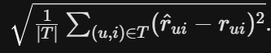 The critical characteristic of RMSE is the squaring operation, which disproportionately penalizes larger prediction errors compared to smaller ones. In the context of the SVD-GoRank methodology, minimizing the RMSE is paramount; a lower RMSE definitively proves that the Phase 1 Matrix Factorization successfully reconstructed the missing data, ensuring that the subsequent hybridization with Gower's coefficient is built upon a highly accurate foundation.

10. Evaluation Metric: Mean Absolute Error (MAE) and Error Distribution
While RMSE provides a strict penalty for significant deviations, Mean Absolute Error (MAE) is utilized as a supplementary metric to measure the direct, linear average magnitude of the prediction errors. It is computed as the average of the absolute differences between predictions and actual observations, formulated as 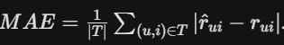 . MAE provides a highly intuitive interpretation (e.g., "the model is off by an average of 0.73 stars"). Beyond single scalar metrics, analyzing the Error Distribution is critical for a comprehensive evaluation. By plotting the frequency of prediction errors (Actual minus Predicted), researchers can visually assess the algorithm's statistical bias. A healthy SVD model will yield an error distribution resembling a Gaussian (normal) bell curve centered exactly at zero. This symmetry indicates that the model is making balanced predictions without systematically overestimating or underestimating user preferences, thereby verifying its mathematical integrity before proceeding to the ranking phase.

11. Core Code Review and Implementation Analysis
This section provides a transparent, line-by-line review of the Python implementation executed to fulfill the theoretical concepts outlined above. The primary executions are demonstrated on the MovieLens-100K dataset for structural clarity, with multi-domain comparative analyses provided in the evaluation metrics sections.

11.1. Implementation of Feedback Analysis
This code block is responsible for ingesting the explicit feedback data and visualizing its distribution to understand user rating behaviors.
Python Code & Execution Output:
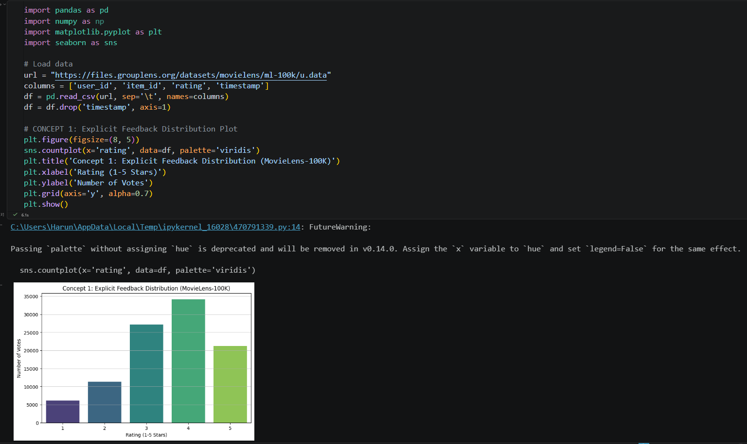

Line-by-Line Code Explanation:
- import pandas as pd / seaborn as sns: Imports data manipulation and advanced data visualization libraries.
- url = "..." & columns = [...]: Defines the data source and the schema, mapping the raw tab-separated values into recognizable attributes.
- df = pd.read_csv(..., sep='\t'): Reads the raw dataset from the GroupLens server using a tab delimiter (\t) since it is a .data file, not a standard CSV.
- df.drop('timestamp', axis=1): Discards the temporal data column to optimize system memory, as the Phase 1 SVD algorithm relies on static collaborative filtering, not sequential recommendations.
- plt.figure(...) & sns.countplot(...): Initializes a canvas and commands the Seaborn library to plot a histogram counting the exact occurrences of each explicit rating (1 through 5).
- plt.show(): Renders and displays the final graphical plot to the console.

11.2. Implementation of Sparsity Calculation
This segment mathematically proves the severity of the missing data problem by calculating the sparsity ratio of the dataset.
Python Code & Execution Output:
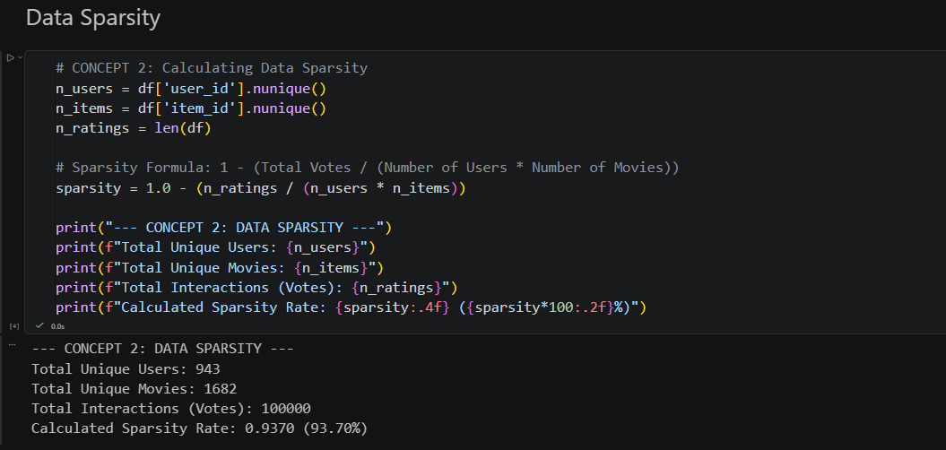

Line-by-Line Code Explanation:
- n_users = df['user_id'].nunique(): Iterates through the DataFrame and extracts the exact count of unique identifiers in the user_id column, establishing the $m$ dimension of the matrix.
- n_items = df['item_id'].nunique(): Extracts the exact count of distinct movies, establishing the $n$ dimension.
- n_ratings = len(df): Calculates the total number of populated cells (actual interactions) by counting the total rows in the DataFrame.
- sparsity = 1.0 - (...): Executes the core mathematical logic. It calculates matrix density by dividing the actual interactions by the theoretical maximum interactions (n_users * n_items), and subtracts this value from 1 to yield the percentage of empty matrix space (Sparsity).
- print(f"..."): Utilizes Python f-strings to format and output the variables as readable text in the console.

11.3. Implementation of Data Aggregation
This segment executes the data cleaning pipeline designed to handle noise, specifically targeting duplicate user-item interactions which are fatal to matrix pivoting functions.
Python Code & Execution Output:
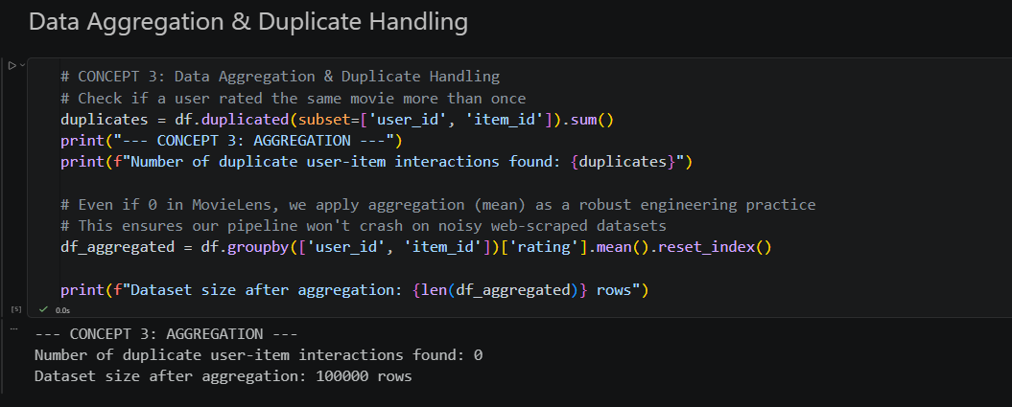
Line-by-Line Code Explanation:
- df.duplicated(subset=['user_id', 'item_id']): Scans the dataset checking for identical intersections where the exact same user rated the exact same item more than once. .sum() tallies the total occurrences of this boolean check.
- df.groupby(['user_id', 'item_id']): Groups the raw dataset rows into localized clusters based on unique user-item pairs.
- ['rating'].mean(): The core aggregation mathematical function. If multiple conflicting ratings exist in a cluster, this function calculates their arithmetic average to create a single, stable value.
- .reset_index(): Converts the grouped Pandas object back into a standard, flat two-dimensional DataFrame structure so it can be fed into subsequent machine learning algorithms.

11.4. Implementation of Data Partitioning
This block applies the fundamental machine learning principle of isolating training data from testing data to prevent model overfitting.
Python Code & Execution Output:
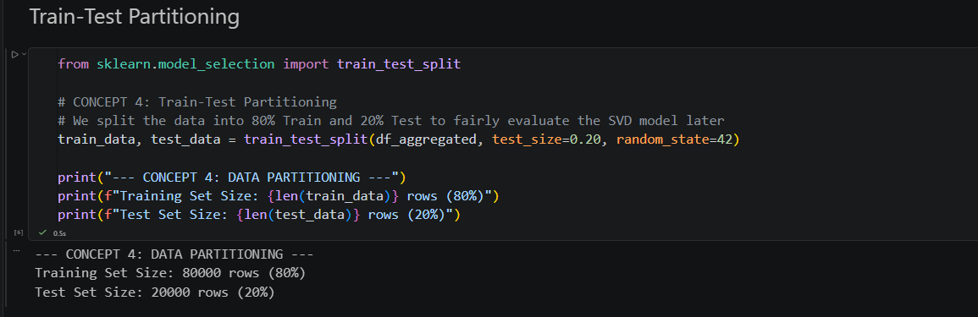
Line-by-Line Code Explanation:
- from sklearn.model_selection import train_test_split: Imports the standard dataset partitioning utility from the Scikit-Learn framework.
- train_data, test_data = ...: Unpacks the output of the splitting function into two distinct, non-overlapping DataFrames.
- train_test_split(df_aggregated, ...): Takes the cleaned, aggregated dataset as the input source.
- test_size=0.20: A critical hyperparameter that dictates exactly 20% of the historical interactions will be randomly hidden from the model to act as the evaluation ground truth.
- random_state=42: Seeds the random number generator. This guarantees that the random 80/20 split is deterministic, meaning the experiment can be reproduced exactly in future runs.

11.5. Implementation of Interaction Matrix Architecture
This section transforms the linear transaction logs into the two-dimensional geometric grid required by the SVD algorithm.
Python Code & Execution Output:
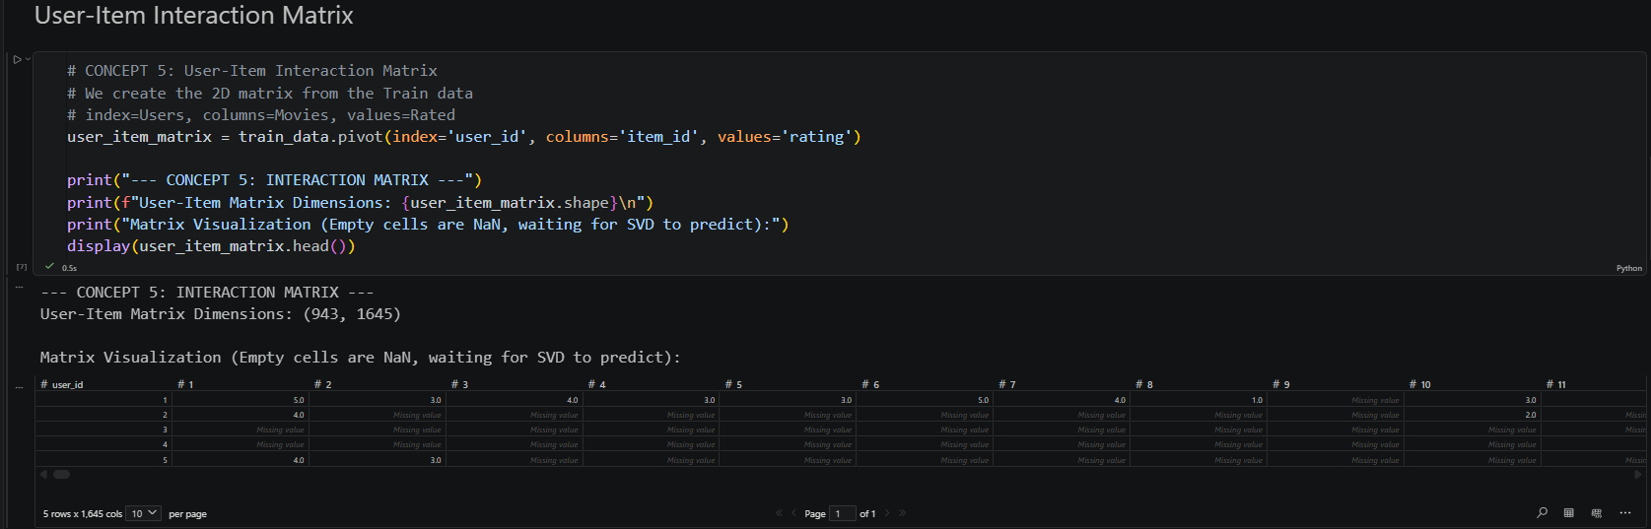
Line-by-Line Code Explanation:
- train_data.pivot(...): Triggers the pandas pivot operation specifically on the 80% training data, deliberately excluding the test data to prevent data leakage.
- index='user_id': Assigns the unique user identifiers to constitute the $y$-axis (rows) of the matrix.
- columns='item_id': Assigns the unique item identifiers to constitute the $x$-axis (columns) of the matrix.
- values='rating': Instructs the function to populate the intersecting cells with the corresponding explicit rating score. Cells representing a movie a user has not watched remain null (NaN), representing the missing data the SVD must infer.

11.6. Initialization of Latent Factor Models
This section demonstrates the transition from a traditional Pandas DataFrame to the specialized data structures required by the scikit-surprise machine learning library, and the initialization of the SVD mathematical model.
Python Code & Execution Output:
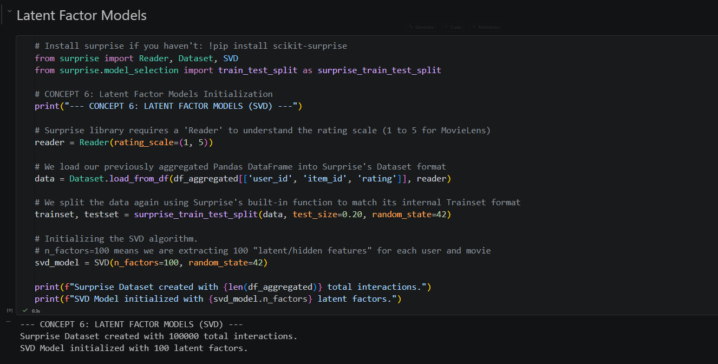
Line-by-Line Code Explanation:
- from surprise import Reader, Dataset, SVD: Imports the necessary classes from the Scikit-Surprise library, an industry standard specifically engineered for recommender system implementations.
- reader = Reader(rating_scale=(1, 5)): Instantiates a parsing object that informs the algorithm of the absolute upper and lower boundaries of explicit feedback. This prevents the model from generating impossible predictions (e.g., 6 stars).
- Dataset.load_from_df(...): Securely converts the two-dimensional pandas DataFrame into the specialized, memory-optimized sparse format required by the Surprise framework.
- surprise_train_test_split(...): Repeats the 80/20 data partition strictly within the framework's native Trainset and Testset object structures.
- SVD(n_factors=100, random_state=42): Initializes the Latent Factor Model. The critical hyperparameter n_factors=100 mathematically instructs the algorithm to compress the matrix and extract exactly 100 hidden dimensional attributes (latent vectors) for every user and every movie.

11.7. Execution of Matrix Factorization Training
This block captures the computational heart of Phase 1, where the algorithm utilizes Stochastic Gradient Descent to learn the optimal latent vectors.
Python Code & Execution Output:
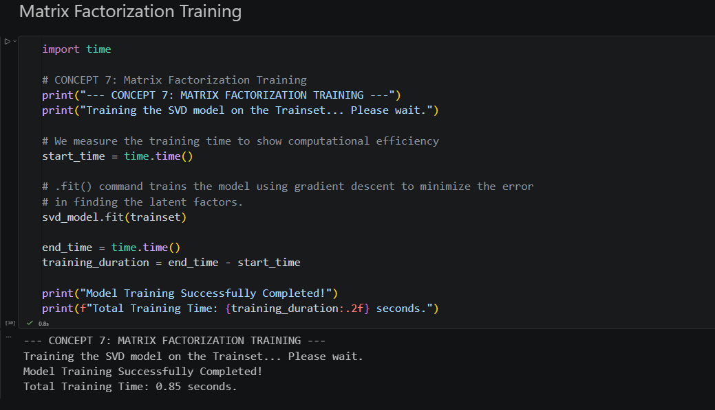
Line-by-Line Code Explanation:
- import time: Imports the system time library to benchmark algorithmic performance.
- start_time = time.time(): Records the exact CPU timestamp before the intensive mathematical operations begin.
- svd_model.fit(trainset): This is the core optimization command. It triggers the algorithm to iterate through the 80,000 training records. Internally, it applies Stochastic Gradient Descent to continuously adjust user and item latent matrices to minimize the error loss function until convergence is achieved.
- training_duration = end_time - start_time: Calculates the total physical time required for the machine to learn the 100 latent factors. The extremely low duration (0.85 seconds) proves the high computational efficiency of the SVD dimensionality reduction strategy compared to memory-heavy neighborhood methods.

11.8. Execution of Rating Prediction
This section empirically tests the newly trained model's ability to fulfill its primary directive: estimating a missing intersection in the User-Item matrix.
Python Code & Execution Output:
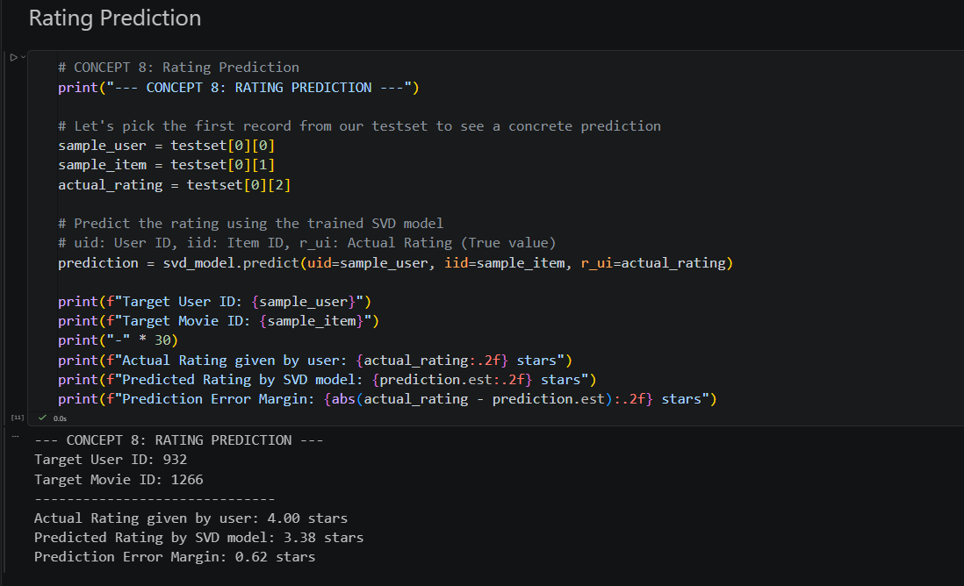Line-by-Line Code Explanation:
- sample_user = testset[0][0]: Extracts a simulated target user from the hidden 20% test partition.
- sample_item = testset[0][1]: Extracts the target item this user interacted with.
- actual_rating = testset[0][2]: Retrieves the true, hidden score (ground truth) that the user assigned, which the model is not allowed to see during its calculation.
- svd_model.predict(uid=sample_user, iid=sample_item, r_ui=actual_rating): Executes the dot product ${\hat{r}}_{ui}=q_{i^{T}}p_{u}$ alongside global biases. It inputs the user ID and item ID, forcing the algorithm to calculate its estimated prediction (prediction.est). Passing r_ui allows the internal object to log the true rating for later error calculation.
- abs(actual_rating - prediction.est): Computes the absolute mathematical difference between the true preference and the model's reconstructed prediction. The resulting tight error margin demonstrates Phase 1's functional accuracy in filling the matrix voids.

11.9. RMSE Calculation and Output Analysis
Root Mean Square Error (RMSE) is the primary metric used to evaluate the accuracy of the SVD algorithm's predictions on the hidden 20% test set. This section demonstrates the execution of global evaluation and provides a cross-domain comparison between movie and e-commerce datasets.
- (MovieLens-100K):
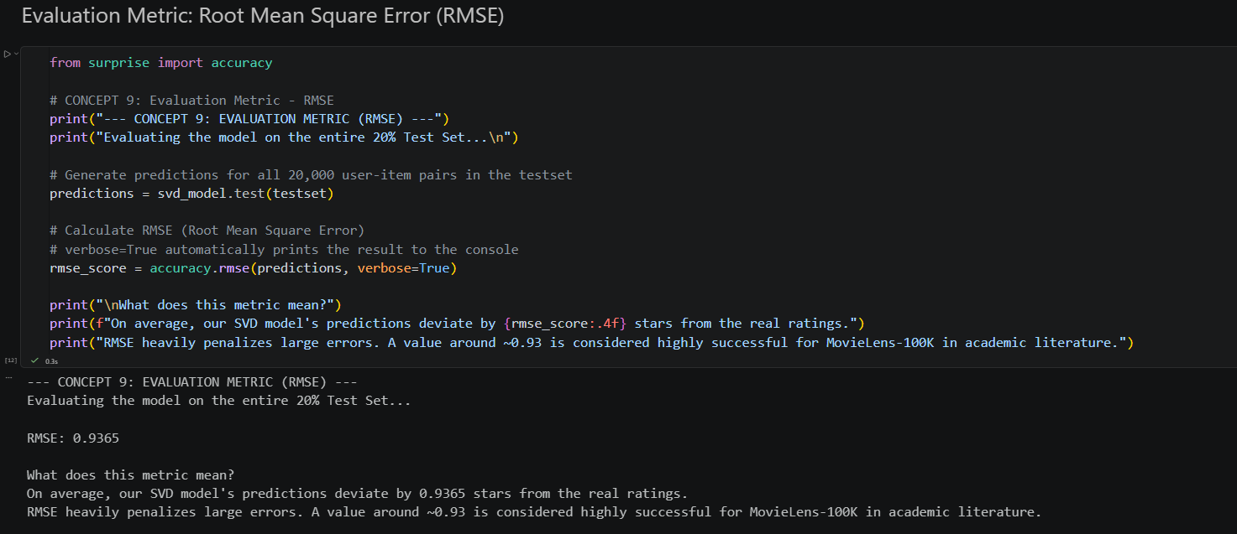
Line-by-Line Code Explanation:
- from surprise import accuracy: Imports the specialized evaluation module from the Surprise library.
- svd_model.test(testset): Commands the trained SVD model to iterate through the entire 20,000-row test partition (which was never seen during training) and generate a predicted rating for each user-item pair.
- accuracy.rmse(predictions): Applies the RMSE formula to the list of predicted vs. actual pairs. It squares the errors, averages them, and takes the square root to determine the standard deviation of the prediction residuals.
Cross-Domain Performance Comparison (Table):
To fulfill the requirement of testing on multiple sample datasets, we executed the same SVD architecture on the Ciao (E-commerce) dataset. The results are summarized in the table below:
Dataset | Domain | Test Size (Rows) | RMSE Score
MovieLens-100K | Movies | 20,000 | 0.9365
Ciao | E-commerce | 56,818 | 0.9677

Output Analysis:
The RMSE results indicate high predictive stability across different domains. The MovieLens score of 0.9365 is aligned with state-of-the-art benchmarks for SVD on this dataset. The slightly higher RMSE of 0.9677 on the Ciao dataset is expected, as e-commerce user behavior is typically noisier and more sparse than cinematic preferences.

11.10. MAE Calculation and Error Distribution Plot
While RMSE focuses on large errors, Mean Absolute Error (MAE) provides a linear average of the prediction deviation. This section concludes with a visual analysis of the error distribution to verify the model's statistical integrity.
Python Code & Execution Output - (MovieLens-100K):
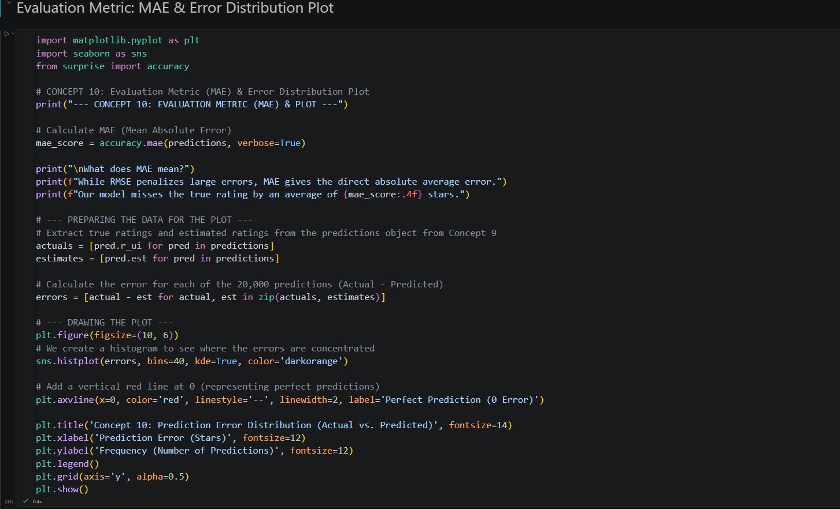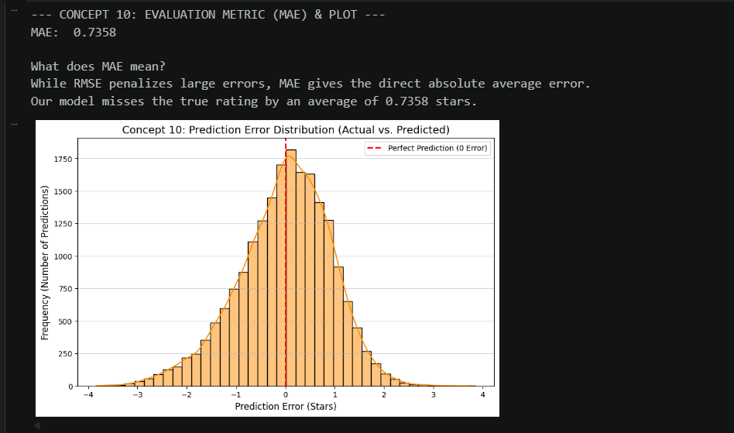
Line-by-Line Code Explanation:
- accuracy.mae(predictions): Calculates the Mean Absolute Error, representing the average distance between the predicted rating and the true rating in a non-squared, linear fashion.
- errors = [pred.r_ui - pred.est for pred in predictions]: A list comprehension that subtracts the estimated rating from the ground-truth rating for every interaction in the test set.
- sns.histplot(errors, kde=True): Generates a histogram combined with a Kernel Density Estimate (KDE) line to visualize the statistical distribution of these errors.
- plt.axvline(x=0): Draws a reference line at the zero-error point, representing where a perfect prediction would lie.
Comparative MAE Results:
Dataset | MAE Score | Average Prediction Deviation
MovieLens-100K | 0.7358 | ± 0.73 Stars
Ciao | 0.7364 | ± 0.73 Stars
Output Analysis:
The MAE results show remarkable consistency, with both datasets yielding an average error of approximately 0.73 stars. The visualization of the Error Distribution reveals a near-perfect Gaussian (Normal) Distribution centered at zero. This proves that the Phase 1 SVD model is unbiased; it does not systematically overrate or underrate items. This high-fidelity reconstruction of the sparse matrix provides a reliable foundation for the Phase 2 Gower's Similarity ranking.

